The goal of the Carmel Green Teen Micro-Grant Program is to challenge area youth to use their skills, creativity and energy to help make Carmel / Clay Township in Indiana a greener community.

Created, developed, and administered by teens, this program empowers young people to take action by funding youth-driven projects that reduce pollution, conserve natural resources, and/or save energy.

The program has been financed through a generous $5,000 donation from the City of Carmel.

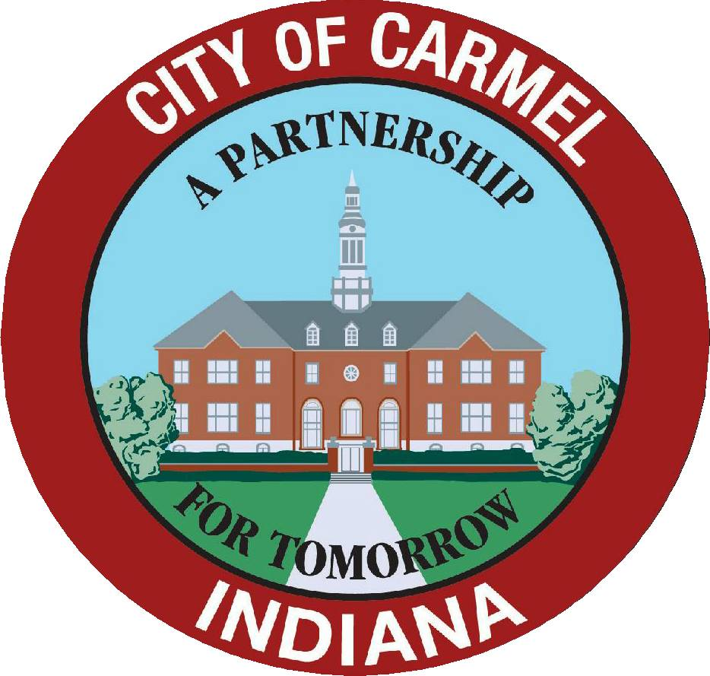

Please continue to visit CarmelGreenTeen.org for photos and details illustrating the environmental and community impact of all Carmel Green Teen youth-led environmental projects.
Welcome, History, and Introductions
Carmel Green Teen Micro-Grant Program Coordinator, Lauren Gibson

Reflection and Recognition
Carmel Mayor Jim Brainard

Introduction of Micro-Grant Recipients & Presentation of Checks
Carmel Green Teen Board youth members: Ema Beeler, Benjamin Gormley, Nicki Hutchins, Charles Liang, Kristen Palamara, Emily Roberts, Bradley Sale, Bridget Stemnock, Ellena Sullivan, Aaron Varnau, Edward Zhang

- Boy Scout Troop 202/St. Elizabeth Ann Seton Church
Bat Boxes: Nature’s Bug Zappers - $750.00
Youth Representative: Duncan Moran

- University High School Students
Tree Hugging Trailblazers - $1,000.00
Youth Representative: Roshni Bag

- Carmel High School Students
Green Shower Power - $750.00
Youth Representative: Tiffany Wang

- Girl Scouts of Central Indiana Troop 801
Bikeyard 100 - $200.00
Youth Representative: Maryann O’Conner

Closing Comments and Photos

Refreshments will be served upon conclusion of the ceremony and group photos. Thank you.

